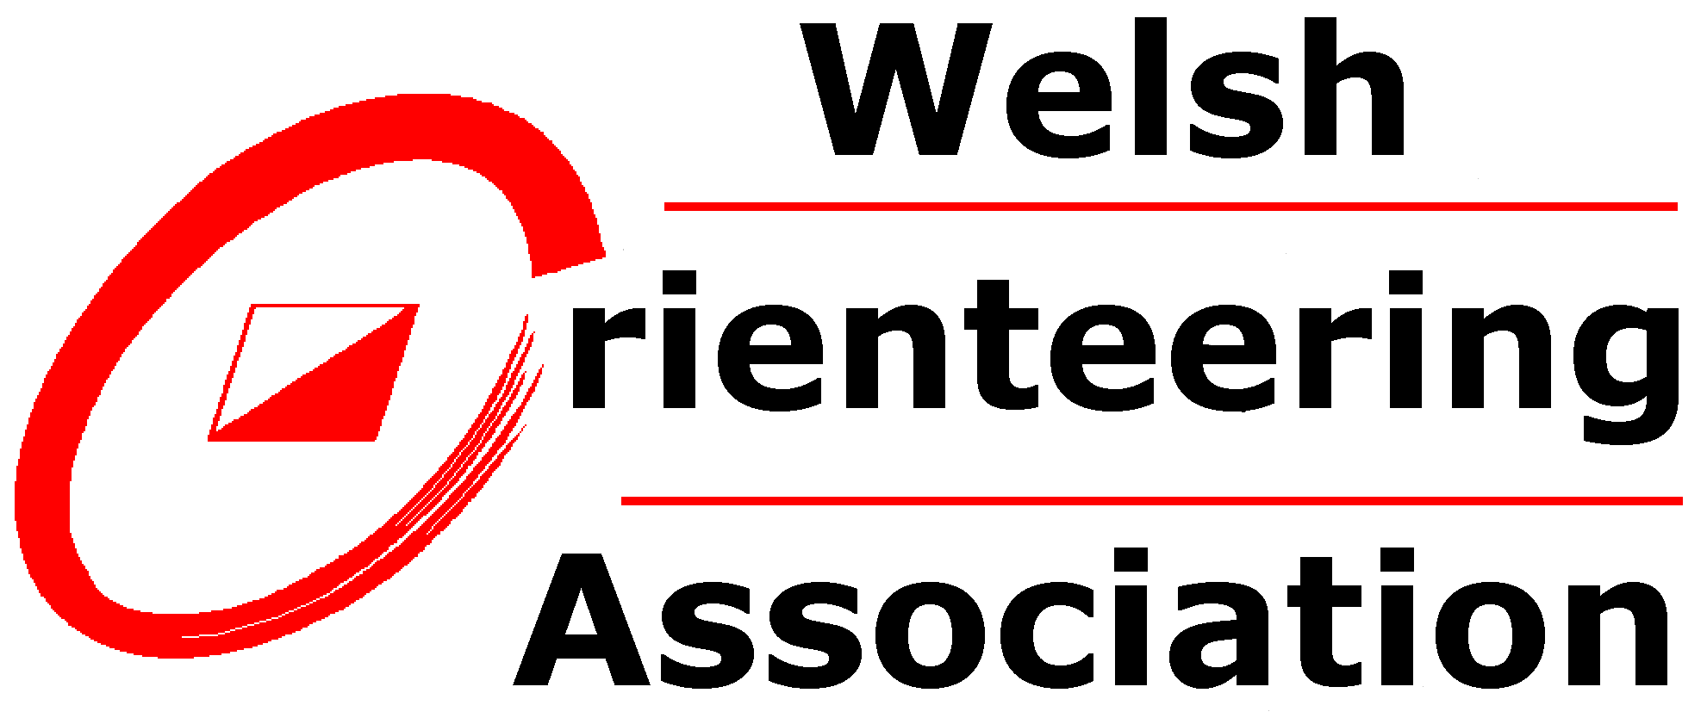

Complaints & Grievance Policy
This policy is based on the British Orienteering Complaints & Grievance Policy with minor amendments where felt appropriate by the Welsh Orienteering Association (WOA). This statement acknowledges the use of British Orienteering’s policy as the basis of developing this policy.
Adopted on: 17th February 2021
Date for review: 17th February 2024
Complaints can be raised by any person whether they are a member of WOA or member of the public and the complaint will be considered and if appropriate investigated.
Grievances occur when you have been affected by an action someone has taken in an unfair or unjust way. It is important that if you feel dissatisfied with any matter relating to your membership or work on behalf of orienteering be it paid or unpaid, you should have a means by which such a grievance can be aired and resolved.
This procedure applies to complaints and all WOA members’ grievances which arise from their involvement with orienteering in a voluntary or paid capacity or employees’ grievances which relate to or arise from the terms of their employment except matters of discipline. In relation to this policy an employee is defined as a person paid to carry out a specific role for a specified period of time such as a professional cartographer, or a coach undertaking a defined programme where payment is made directly by WOA and they are responsible for developing and overseeing the contract of work.
Procedure
WOA encourages that all complaints or grievances should be managed at the closest point to the issue. Nothing in this policy is intended to prevent you from informally raising any matter you may wish to mention. Informal discussion can frequently solve problems without the need for a written record. However, should informal discussion not resolve the complaint or grievance, then it should be made clear that there is a wish for the complaint or grievance to be formally recorded and investigated at the stage when the informal discussion fails to satisfactorily resolve any problem.
If the complaint or grievance is related to a matter of personal harassment then contact with the WOA Safeguarding Officer should be made; their contact details can be found on the WOA website.
If you feel aggrieved at any other matter relating to orienteering, your membership or your work paid or unpaid, you should:
(a) First raise the matter with the person responsible for the matter, which may be a club Chair, event organiser or line manager either verbally or in writing, explaining the nature and extent of your complaint or grievance.
(b) If the complaint or grievance is not resolved satisfactorily, or if it is not possible due to the nature of the complaint or grievance to approach the responsible person, you should decide whether to raise this with the Welsh Orienteering Association or British Orienteering. WOA will be unable to investigate any complaint or grievance that has been raised directly with British Orienteering but will cooperate with any enquiries that British Orienteering makes in their investigations of the complaint or grievance. If the matter is being raised with WOA then in the first instance it should be notified to the WOA Secretary, or if the person responsible is the WOA Secretary, the matter should be discussed with the Chair of WOA. The notification should be made in writing and must include the name of the person making the complaint, their age, a contact address and a description of the allegation. Anonymous complaints will not be investigated but should a person feel they will be adversely affected by making a complaint then they are advised to contact the WOA secretary in advance of making the complaint so an agreed pseudonym can be attached to the complaint that only the complainant and WOA secretary would know.
(c) The aggrieved person has the right to consult with a person of their choice at any stage of the procedure. They may also choose a representative to be present at any meeting arranged for the purpose of resolving a complaint or grievance to help you to explain the situation more clearly. It is the responsibility of the aggrieved individual to keep their representative fully informed.
(d) Details of all complaints or grievances raised under this procedure will be fully documented and in the case of employees retained on file with the contract documentation by the WOA Secretary.
(e) If a satisfactory solution cannot be reached by these discussions, a written statement should be sent to the WOA Secretary (or in a case where the complaint or grievance is against the WOA Secretary, the Chair of WOA) setting out full details of the situation giving rise to the complaint or grievance. The matter shall then be referred to the Appeal Panel in line with the WOA Appeal of Decision Policy, which will make a final decision on the matter. This is the final stage of the complaint and grievance procedure.
(f) Complaints and grievances will be dealt with as promptly as possible relative to the individual circumstances of each case. Where a complaint or grievance request has been formally recorded, an initial consultation (which may be by phone or interview) will normally be convened within 21 days for members and 3 working days for employees.

